**Big Mountain Resort Pricing Report**

Big Mountain Resort (BMR) has enlisted our support in analyzing its current pricing scheme and a few possible scenarios regarding improving profitability. Our report will cover their current situation, our charge in terms of analysis, core key findings, and recommendations. To begin with BMR is a ski resort located in Montana, that hired our firm to specifically identify if its current price of **$81** (we use Weekend prices based on data availability) was below what the resort could reasonably charge. Our model (which will be explicated further) predicts that BMR could reasonably charge a price of **$95.87** for Weekends and not see a significant drop in attendance (assuming no other changes to BMR’s operations). The data supports the notion that BMR’s current price level is below what is justified based on their offerings.

Our initial model is built on the simple notion of comparing similar ski resorts to BMR (and which BMR identified as potential competitors) and evaluating the prices they charge based on characteristics of the ski resort using the Random Forest methodology. In course of building our model, 8 characteristics were identified to base our analysis on which are listed below:

* Vertical Drop: The vertical distance between the high and low points of the ski resort
* Snow Making Coverage: Area of the ski resort that has snowmaking capabilities
* Total Chairs: The total number of chairs available to skiers
* Fast Quads: The number of fast quad trams available to skiers
* Runs: The number of unique runs a skier can take
* Longest Run: The longest run available that a skier could take
* Trams: The total number of trams available to skiers
* Skiable Terrian: The area of total skiable terrain at a resort

We settled on these 8 characteristics because they provided the best balance of building a model that accurately predicted the price of our training sets while not becoming overly specialized. It is possible to overly specialize a model to a specific data set, resulting in it being extremely accurate for a training set, but then become on average less accurate as you apply it to your testing set, which is used to evaluate the efficacy of a model. The following graphic captures this phenomenon (the horizontal access is the number of characteristics to include in our model while the vertical axis is a composite measure of accuracy and variance):

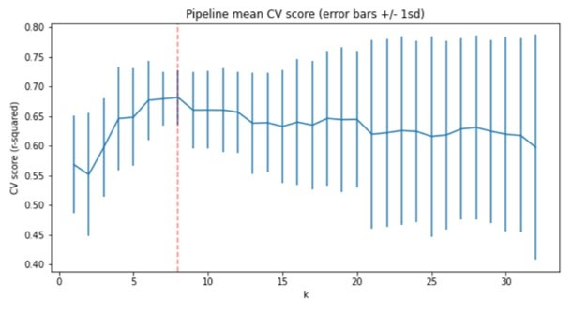

As you can see, going above 8 characteristics seem to result in overspecialization. However, we wanted to also consider if there was a more suitable model for analysis as another charge from the client was to consider possible operating changes to the resort. BMR asked us to evaluate four possible alternative scenarios (BMR provided an estimate that installing a new chair lift would cost ~$1,540,000 for the upcoming ski season):

1. Closing up to 10 of the least used runs
2. Adding an additional chair lift which enables increasing the vertical drop and adding an additional run
3. Adding an additional chair lift which enables increasing the vertical drop and adding an additional run while also adding 2 more acres of snowmaking capabilities
4. Increasing the current longest run’s length by 0.2 miles and guaranteeing snow coverage by adding 4 more acres of snowmaking capabilities

Scenarios 2,3, & 4 represent a combination of operating capacity increases and thus can be compared based on the expected price increase (that could be achieved on top of the recommended price of $95.87)  and resultant revenue increases:

|  |  |  |  |  |
| --- | --- | --- | --- | --- |
|  | Expected Price Increase | Expected Revenue Increase | Expected Cost Increase | Expected Operating Revenue |
| Scenario 2 | $1.12 | $1,952,899 | $1,540,000 | $412,899 |
| Scenario 3 | $1.99 | $3,474,638 | $1,540,000 + Snowcost | ? |
| Scenario 4 | $0.00 | $0.00 | ? | ? |

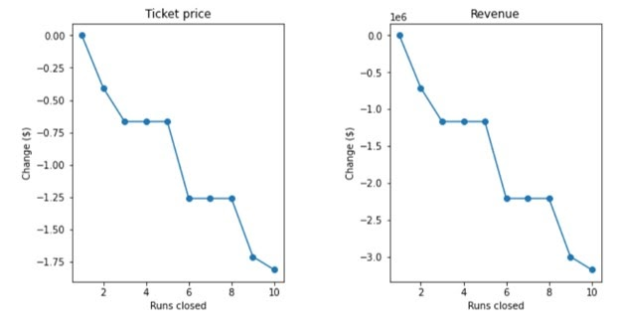 We ultimately recommend Scenario 2 (Adding an additional chair lift which enables

increasing the vertical drop and adding an additional run) for two main reasons. First, nearly all expected changes are known upfront which increases our confidence in the recommendation. Second, it’s tough to properly evaluate the total changes of Scenario 3 without knowing the installation cost and operating cost of increasing snow cover. While the model shows potential gains, it also cannot accurately capture costs that are not known upfront. If management wished to further evaluate this option, we would need to gain a better understanding of the cost of installing more snowmaking capabilities and the operational cost of running it as it may not result in greater operating revenue. Scenario 4 did not show any evidence regarding improving BMR’s ability to increase the price.

Scenario 1 is slightly different to evaluate due to it being a strictly cost-cutting measure that could potentially be done in conjunction with Scenario 2. The following graphs capture the results of the analysis.

The following graphs show how much BMR’s price would need to drop based on the number of runs that were closed (the runs closed are ordered based on the frequency of use with the first run closed being the least frequently used.) We can see that closing a single run (which would be the least used run as the first) would most likely not result in any price decrease, but closing 2 runs would start putting downward pressure on price. In addition, if BMR were to decrease by 3 runs, it would potentially make sense to close 2 additional runs (total 5 closed runs) as it would appear it would have no additional effect on price. Based on this information, management would need to consider the operating costs associated with these runs and whether they would be profitable. At the bare minimum, it would appear BMR could cut the least used run and expect that the ticket price would not be affected.